**Module-2) SE- HTML and CSS**

1) Define the terms: Website, Webpage, Web browser, Web server, HTML,

CSS

Ans) webpage- A web page or webpage is a document, commonly written in HTML, that is viewed in an Internet browser.

Website- A website refers to a central location containing more than one web page.

Web Server- a web server is a computer that stores web server software and a website's component files (for example, HTML documents, images, CSS stylesheets, and JavaScript files). A web server connects to the Internet and supports physical data interchange with other devices connected to the web.

HTML - HTML is an acronym which stands for Hyper Text Markup Language which is used for creating web pages and web applications

CSS- CSS (Cascading Style Sheets) is **a language for styling the webpage**. We can change the appearance and the layout of the webpage by using CSS

2)Create a webpage to show “This is my first HTML page”

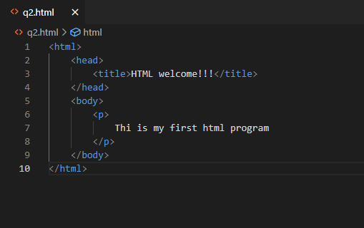

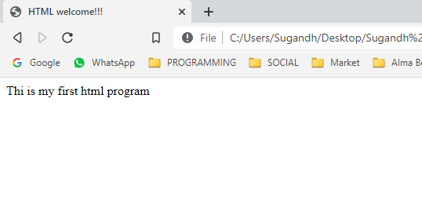

Q3) Display top 10 IT companies list in html webpage

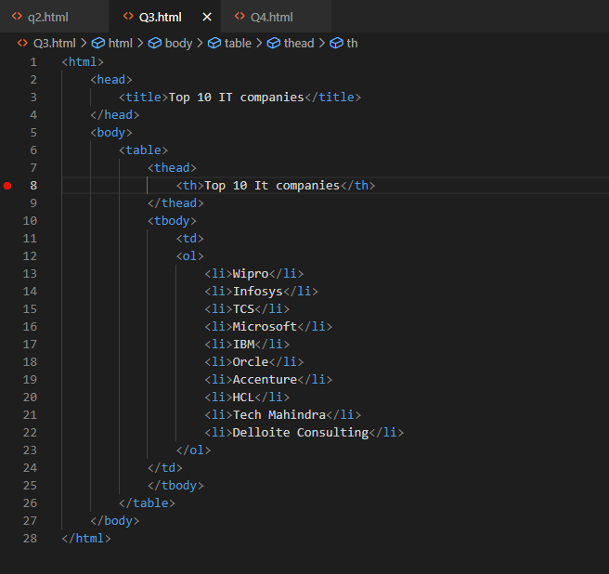

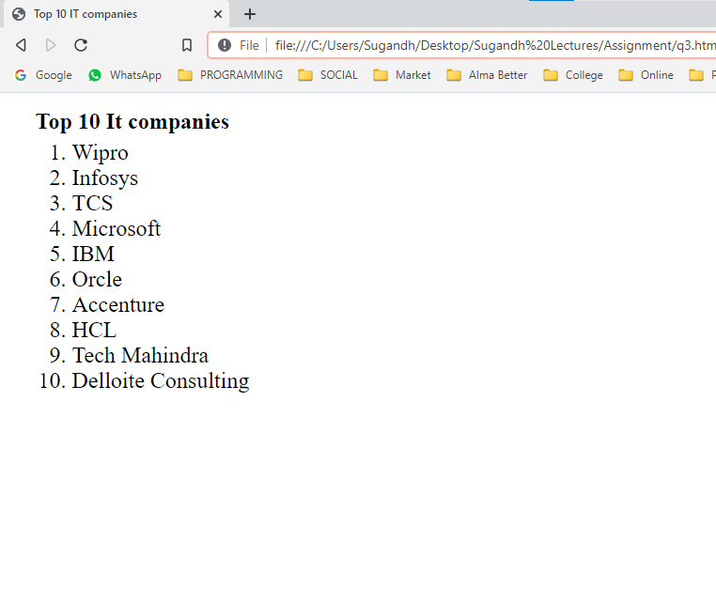

Q4) Create a dropdown list

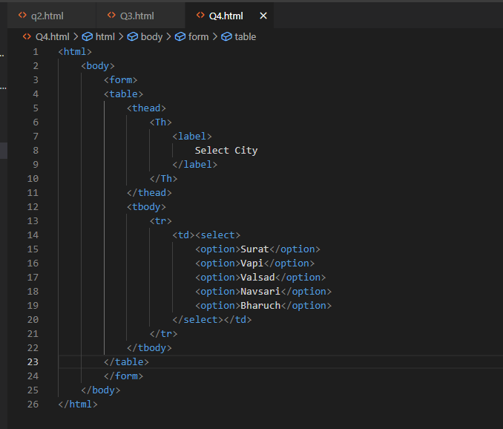

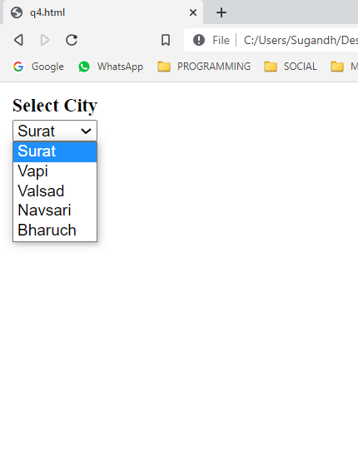

Q5) Create below table using HTML table tags

<!DOCTYPE html>

<html lang="en">

<head>

    <meta charset="UTF-8">

    <meta http-equiv="X-UA-Compatible" content="IE=edge">

    <meta name="viewport" content="width=device-width, initial-scale=1.0">

    <title>Document</title>

    <link rel="stylesheet" href="style.css">

</head>

<body>

    <h1>European Roulette</h1>

    <table border="1" style="width: 100%; height:auto; border-color: white;" rules="all">

        <tr>

            <td rowspan="5">0</td>

            <td style="background-color: red;">3</td>

            <td style="background-color: black;">6</td>

            <td style="background-color: red;">9</td>

            <td style="background-color: red;">12</td>

            <td style="background-color: black;">15</td>

            <td style="background-color: red;">18</td>

            <td style="background-color: red;">21</td>

            <td style="background-color: black;">24</td>

            <td style="background-color: red;">27</td>

            <td style="background-color: red;">30</td>

            <td style="background-color: black;">33</td>

            <td style="background-color: ;">36</td>

            <td>2 to 1</td>

        </tr>

        <tr>

            <td style="background-color: black;">2</td>

            <td style="background-color: red;">5</td>

            <td style="background-color: black;">8</td>

            <td style="background-color: black;">11</td>

            <td style="background-color: red;">14</td>

            <td style="background-color: black;">17</td>

            <td style="background-color: black;">20</td>

            <td style="background-color: red;">23</td>

            <td style="background-color: black;">26</td>

            <td style="background-color: black;">29</td>

            <td style="background-color: red;">32</td>

            <td style="background-color: black;">35</td>

            <td>2 to 1</td>

        </tr>

        <tr>

            <td style="background-color: red;">1</td>

            <td style="background-color: black;">4</td>

            <td style="background-color: red;">7</td>

            <td style="background-color: red;">10</td>

            <td style="background-color: black;">13</td>

            <td style="background-color: black;">16</td>

            <td style="background-color: black;">19</td>

            <td style="background-color: black;">22</td>

            <td style="background-color: black;">25</td>

            <td style="background-color: black;">28</td>

            <td style="background-color: black;">31</td>

            <td style="background-color: black;">34</td>

            <td>2 to 1</td>

        </tr>

        <tr>

            <td colspan="4">1st12</td>

            <td colspan="4">2nd12</td>

            <td colspan="4">3rd12</td>

            <td rowspan="2"></td>

        </tr>

        <tr>

            <td colspan="2">1to18</td>

            <td colspan="2">even</td>

            <td colspan="2" style="background-color: red;"></td>

            <td colspan="2" style="background-color: black;"></td>

            <td colspan="2">odd</td>

            <td colspan="2">19to36</td>

        </tr>

    </table>

</body>

</html>

